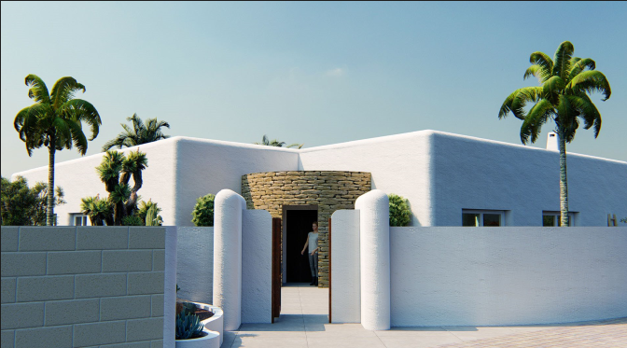


Can Elle
descripción // description
CASTELLANO
Proyecto ibicenco que de articula en disposición en L en planta. Con un volumen de salón-cocina-comedor, una gran cristalera corredera que se oculta en la tabiquería y se abre hacia la zona pergolada y terraza con piscina orientada a sur. El salón con una altura superior a la normal, cálidamente ambientado por tonos de madera en las vigas del techo, paneles en muros y armarios de cocina.
El volumen de zona de noche, dormitorios, baños, lavadero y un despacho, esta articulado con dividido de la zona publica, a través de un hall en forma de rotula que cuenta con un cristal curvo, desplegado hacia la zona de piscina y un olivo que recibe a la persona al entrar a la vivienda.
Cuenta también con un trastero exterior y gran pergola sobre zona de aparcamiento.

ENGLISH
An exclusive Ibiza style Project in a beautiful plot located in Alfaz del Pi, in between “partida el arabi street” and “Mallorca street”, in the El arabi urbanization area.
This is a one storey house that is articulated in “L” shape, having a public volume (kitchen, living room and dining room) and a public volume (3 bedroom, 2 bathroom, 1 office space, 1 laundry/utility room). That are connected by a rounded hall with a curved glass that receives the user when arriving to the house (selfie spot #1), by the look of an olive tree and the big terrace/pool area oriented towards the south.
The private area has a roof height above normal, decorated with wooden beams, wooden wall and kitchen panels. There is a massive large sliding window that is embedded on the wall when closed, connecting to a large pergola area that works as a buffer space in between the interior space and the pool terrace (Selfie spot #2).
The project also has an exterior storage space and a large pergola above the parking area.

